

IEC 62443-3-3
Provided by : www.spic.ir
IEC 62443-3-3:2013(E)
®
Edition 1.0 2013-08

INTERNATIONAL STANDARD


colour inside

Industrial communication networks – Network and system security – Part 3-3: System security requirements and security levels


THIS PUBLICATION IS COPYRIGHT PROTECTED
Copyright © 2013 IEC, Geneva, Switzerland
All rights reserved. Unless otherwise specified, no part of this publication may be reproduced or utilized in any form or by any means, electronic or mechanical, including photocopying and microfilm, without permission in writing from either IEC or IEC's member National Committee in the country of the requester.
If you have any questions about IEC copyright or have an enquiry about obtaining additional rights to this publication, please contact the address below or your local IEC member National Committee for further information.
IEC Central Office 3, rue de Varembé CH-1211 Geneva 20 Switzerland
Tel.: +41 22 919 02 11
Fax: +41 22 919 03 00
info@iec.ch www.iec.ch

About the IEC
The International Electrotechnical Commission (IEC) is the leading global organization that prepares and publishes International Standards for all electrical, electronic and related technologies.

About IEC publications
The technical content of IEC publications is kept under constant review by the IEC. Please make sure that you have the latest edition, a corrigenda or an amendment might have been published.

Useful links:

Provided by : www.spic.ir
IEC publications search - www.iec.ch/searchpub
The advanced search enables you to find IEC publications by a variety of criteria (reference number, text, technical committee,…).
It also gives information on projects, replaced and withdrawn publications.
IEC Just Published - webstore.iec.ch/justpublished
Stay up to date on all new IEC publications. Just Published details all new publications released. Available on-line and also once a month by email.

Electropedia - www.electropedia.org
The world's leading online dictionary of electronic and electrical terms containing more than 30 000 terms and definitions in English and French, with equivalent terms in additional languages. Also known as the International Electrotechnical Vocabulary (IEV) on-line.

Customer Service Centre - webstore.iec.ch/csc
If you wish to give us your feedback on this publication or need further assistance, please contact the Customer Service Centre: csc@iec.ch.


colour inside

Industrial communication networks – Network and system security – Part 3-3: System security requirements and security levels

INTERNATIONAL ELECTROTECHNICAL COMMISSION

ICS 25.040.40; 35.110

PRICE CODE XC

ISBN 978-2-8322-1036-9

Provided by : www.spic.ir

Warning! Make sure that you obtained this publication from an authorized distributor.

® Registered trademark of the International Electrotechnical Commission

Provided by : www.spic.ir
CONTENTS
FOREWORD 9
- Introduction 11
  - Overview 11
  - Purpose and intended audience 12
  - Usage within other parts of the IEC 62443 series 12
- Scope 14
- Normative references 14
- Terms, definitions, abbreviated terms, acronyms, and conventions 14
  - Terms and definitions 14
  - Abbreviated terms and acronyms 20
  - Conventions 22
- Common control system security constraints 22
  - Overview 22
  - Support of essential functions 23
  - Compensating countermeasures 23
  - Least privilege 24
- FR 1 – Identification and authentication control 24
  - Purpose and SL-C(IAC) descriptions 24
  - Rationale 24
  - SR 1.1 – Human user identification and authentication 24
    - Requirement 24
    - Rationale and supplemental guidance 24
    - Requirement enhancements 25
    - Security levels 25
  - SR 1.2 – Software process and device identification and authentication 26
    - Requirement 26
    - Rationale and supplemental guidance 26
    - Requirement enhancements 26
    - Security levels 27
  - SR 1.3 – Account management 27
    - Requirement 27
    - Rationale and supplemental guidance 27
    - Requirement enhancements 27
    - Security levels 27
  - SR 1.4 – Identifier management 28
    - Requirement 28
    - Rationale and supplemental guidance 28
    - Requirement enhancements 28
    - Security levels 28
  - SR 1.5 – Authenticator management 28
    - Requirement 28
    - Rationale and supplemental guidance 28
    - Requirement enhancements 29
    - Security levels 29
  - SR 1.6 – Wireless access management 30
    - Requirement 30

Provided by : www.spic.ir
INTERNATIONAL ELECTROTECHNICAL COMMISSION

INDUSTRIAL COMMUNICATION NETWORKS – NETWORK AND SYSTEM SECURITY –

Part 3-3: System security requirements and security levels

FOREWORD
- The International Electrotechnical Commission (IEC) is a worldwide organization for standardization comprising all national electrotechnical committees (IEC National Committees). The object of IEC is to promote international co-operation on all questions concerning standardization in the electrical and electronic fields. To this end and in addition to other activities, IEC publishes International Standards, Technical Specifications, Technical Reports, Publicly Available Specifications (PAS) and Guides (hereafter referred to as “IEC Publication(s)”). Their preparation is entrusted to technical committees; any IEC National Committee interested in the subject dealt with may participate in this preparatory work. International, governmental and non- governmental organizations liaising with the IEC also participate in this preparation. IEC collaborates closely with the International Organization for Standardization (ISO) in accordance with conditions determined by agreement between the two organizations.
- The formal decisions or agreements of IEC on technical matters express, as nearly as possible, an international consensus of opinion on the relevant subjects since each technical committee has representation from all interested IEC National Committees.
- IEC Publications have the form of recommendations for international use and are accepted by IEC National Committees in that sense. While all reasonable efforts are made to ensure that the technical content of IEC Publications is accurate, IEC cannot be held responsible for the way in which they are used or for any misinterpretation by any end user.
- In order to promote international uniformity, IEC National Committees undertake to apply IEC Publications transparently to the maximum extent possible in their national and regional publications. Any divergence between any IEC Publication and the corresponding national or regional publication shall be clearly indicated in the latter.
- IEC itself does not provide any attestation of conformity. Independent certification bodies provide conformity assessment services and, in some areas, access to IEC marks of conformity. IEC is not responsible for any services carried out by independent certification bodies.
- All users should ensure that they have the latest edition of this publication.
- No liability shall attach to IEC or its directors, employees, servants or agents including individual experts and members of its technical committees and IEC National Committees for any personal injury, property damage or other damage of any nature whatsoever, whether direct or indirect, or for costs (including legal fees) and expenses arising out of the publication, use of, or reliance upon, this IEC Publication or any other IEC Publications.
- Attention is drawn to the Normative references cited in this publication. Use of the referenced publications is indispensable for the correct application of this publication.
- Attention is drawn to the possibility that some of the elements of this IEC Publication may be the subject of patent rights. IEC shall not be held responsible for identifying any or all such patent rights.

International Standard IEC 62443-3-3 has been prepared by IEC technical committee 65: Industrial-process measurement, control and automation.

The text of this standard is based on the following documents:

FDIS | Report on voting
65/531/FDIS | 65/540/RVD

Full information on the voting for the approval of this standard can be found in the report on voting indicated in the above table.

This publication has been drafted in accordance with the ISO/IEC Directives, Part 2.

Provided by : www.spic.ir
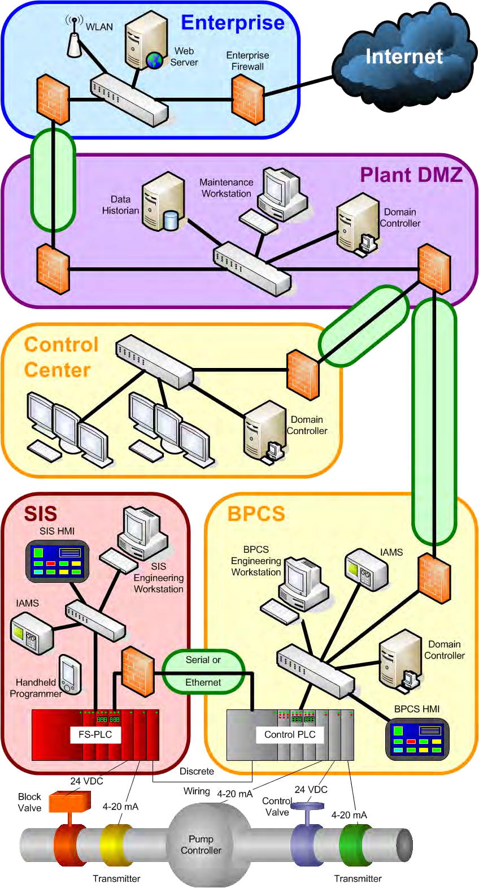
IEC 2032/13

Figure A.1 – High-level process-industry example showing zones and conduits

Figure A.2 is a graphical representation of a manufacturing plant. It has four zones defined: the enterprise network, the industrial/enterprise DMZ, and two industrial networks. The enterprise infrastructure has a WLAN and a connection to the Internet. Many companies use a DMZ between important parts of their systems to isolate the network traffic. In this particular example, each industrial network operates relatively independent of each other with its own PLC, field devices, and HMI.

Provided by : www.spic.ir
Provided by : www.spic.ir

Annex B
(informative)

Mapping of SRs and REs to FR SL levels 1-4

Overview

This annex is intended to provide overall guidance to the reader as to how SL levels 0 to 4 are differentiated on an FR-by-FR basis via the defined SRs and their associated REs.

Table B.1 – Mapping of SRs and REs to FR SL levels 1-4 (1 of 4)

 |  | SRs and REs |  | SL 1 | SL 2 | SL 3 | SL 4
FR 1 – Identification and authentication control (IAC)
SR 1.1 – Human user identification and authentication |  |  | 5.3 | ✓ | ✓ | ✓ | ✓
SR 1.1 RE 1 – Unique identification and authentication |  |  | 5.3.3.1 |  | ✓ | ✓ | ✓
SR 1.1 RE 2 – Multifactor authentication for untrusted networks |  |  | 5.3.3.2 |  |  | ✓ | ✓
SR 1.1 RE 3 – Multifactor authentication for all networks |  |  | 5.3.3.3 |  |  |  | ✓
SR 1.2 – Software process and device identification and authentication |  |  | 5.4 |  | ✓ | ✓ | ✓
SR 1.2 RE 1 – Unique identification and authentication |  |  | 5.4.3.1 |  |  | ✓ | ✓
SR 1.3 – Account management |  |  | 5.5 | ✓ | ✓ | ✓ | ✓
SR 1.3 RE 1 – Unified account management |  |  | 5.5.3.1 |  |  | ✓ | ✓
SR 1.4 – Identifier management |  |  | 5.6 | ✓ | ✓ | ✓ | ✓
SR 1.5 – Authenticator management |  |  | 5.7 | ✓ | ✓ | ✓ | ✓
SR 1.5 RE 1 – Hardware security for software process identity credentials |  |  | 5.7.3.1 |  |  | ✓ | ✓
SR | 1.6 | – Wireless access management | 5.8 | ✓ | ✓ | ✓ | ✓
SR 1.6 RE 1 – Unique identification and authentication |  |  | 5.8.3.1 |  | ✓ | ✓ | ✓
SR 1.7 – Strength of password-based authentication |  |  | 5.9 | ✓ | ✓ | ✓ | ✓
SR 1.7 RE 1 – Password generation and lifetime restrictions for human users |  |  | 5.9.3.1 |  |  | ✓ | ✓

Provided by : www.spic.ir
Provided by : www.spic.ir
Provided by : www.spic.ir

